**A PROJECT REPORT**

On

**HEALTH AI**

(Intelligent Healthcare Assistant Using IBM Granite)

By

Mamidala yaswanth

(22FE1A4226)

Under the guidance of

**Ganesh M**

**TABLE OF CONTENTS**

|  |  |  |
| --- | --- | --- |
| S.NO | CONTENT | PAGE NOs |
| 1. | |  | | --- | | Abstract |  |  | | --- | |  | | 3 |
| 2. | |  | | --- | | Introduction |  |  | | --- | |  | | 4 |
| 3. | |  | | --- | | Module Description |  |  | | --- | |  | | 5-6 |
| 4. | |  | | --- | | User Interface |  |  | | --- | |  | | 7-8 |
| 5. | Testing | 9-10 |
| 6 | |  | | --- | | Result |  |  | | --- | |  | | 11-12 |
| 7. | |  | | --- | | Future Enhancements |  |  | | --- | |  | | 13 |
| 8. | Conclusion | 14 |

**ABSTRACT**

**HealthAI** is an innovative AI-driven healthcare assistant designed to deliver accurate, personalized, and accessible medical guidance using cutting-edge technologies. It integrates **IBM Watson Machine Learning** and the **Granite-13b-instruct-v2** generative model to simulate intelligent, human-like interactions for a variety of healthcare use cases.

The platform empowers users to:

* Receive instant answers to health-related questions via **Patient Chat**.
* Analyze reported symptoms through **Disease Prediction** to determine likely medical conditions.
* Obtain evidence-based, tailored **Treatment Plans** for diagnosed issues.
* Monitor and interpret personal health trends using **Health Analytics** with visual insights.

By leveraging the power of **Streamlit** for the frontend and **IBM WatsonX APIs** for AI processing, HealthAI ensures a seamless and intuitive user experience. The system incorporates secure API key management, responsive UI design, and modular architecture to facilitate real-time interaction and feedback while protecting user data.

Unlike traditional health portals that rely solely on static content, HealthAI provides **dynamic, context-aware responses** grounded in generative AI capabilities. Its ability to process free-form natural language inputs and convert them into medically relevant outputs enhances its utility as a virtual healthcare companion.

The ultimate goal of HealthAI is not to replace doctors but to bridge the gap between individuals and professional medical help by offering **first-level triage, guidance, and education**. With future integration of wearable data and multilingual support, HealthAI is positioned as a forward-thinking solution to meet the growing demand for **AI-assisted personal healthcare management**.

**INTRODUCTION**

The evolution of Artificial Intelligence (AI) in healthcare has opened up transformative possibilities, particularly in improving accessibility, early detection, and personalized medical guidance. In this context, **HealthAI** emerges as a cutting-edge healthcare assistant platform that utilizes **IBM Watson Machine Learning** and the **Granite-13b-instruct-v2 generative model** to provide users with intelligent, real-time medical support.

HealthAI is built with a **patient-first approach**, aiming to offer reliable and interactive health-related assistance to users without requiring prior medical knowledge. The platform integrates four core modules:

1. **Patient Chat** – A natural language interface where users can ask any health-related questions and receive AI-generated, empathetic, and informative responses.
2. **Disease Prediction** – Analyzes reported symptoms to provide likely conditions, including potential diagnoses and probability estimates.
3. **Treatment Plan Generator** – Offers evidence-based medical recommendations tailored to individual conditions and profiles.
4. **Health Analytics** – Allows users to input or upload their health data (like vitals) and view trends or alerts through AI-generated visual analysis.

The frontend is developed using **Streamlit**, a powerful and simple Python-based web application framework that allows for rapid development of responsive UIs. It ensures user-friendliness, fast prototyping, and clean visualization of health metrics. On the backend, **IBM WatsonX APIs** connect to the **Granite-13b-instruct-v2** language model, which handles user inputs with advanced natural language processing (NLP) and generates medically relevant and context-aware responses.

Key design principles of HealthAI include:

* **Security**: All sensitive data and API credentials are managed using secure .env configurations.
* **Modularity**: The platform architecture is built in a modular fashion to support future scalability and integration with external health systems.
* **Transparency and Responsibility**: HealthAI is not intended to replace professional healthcare providers. Instead, it provides guidance that encourages users to seek proper medical consultation where necessary.

In a world where millions lack immediate access to quality healthcare or medical advice, HealthAI acts as a virtual bridge—enabling anyone with an internet connection to gain initial medical support, education, and actionable insights. The project showcases how generative AI can be responsibly applied to a sensitive domain like healthcare, making it smarter, safer, and more accessible to all.

**Module Description**

**3.1 Project Overview**

HealthAI combines four core functionalities:

* Patient Chat for answering medical questions
* Disease Prediction from symptoms
* Treatment Plan Generator based on diagnosed conditions
* Health Analytics for visualizing health metrics  
  The goal is to empower patients with AI-driven insights and bridge the information gap between symptoms and diagnosis.

**3.2 Architecture**

* **Frontend:** Streamlit (Python-based web framework)
* **Backend:** IBM WatsonX APIs connected to Granite-13b model
* **Security:** Handled through .env for API key protection
* **Visualization:** Charts built using Plotly/Matplotlib

**3.3 Folder Structure**

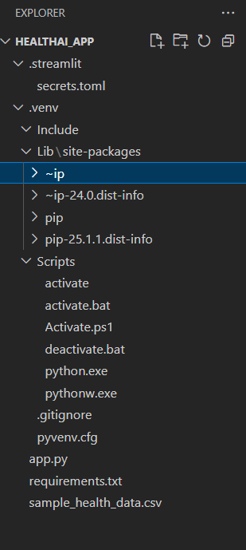

/app # Streamlit frontend

/api # Python scripts to connect with WatsonX

/utils # Helper functions

.env # Secured API credentials

**3.4 Functional Scenarios**

* Scenario 1 – Disease Prediction:  
  User inputs symptoms like fatigue, fever, headache. The model predicts potential illnesses (e.g., flu, migraine) with probabilities.
* Scenario 2 – Treatment Plans:  
  Given a condition like "Diabetes", the AI suggests diet plans, medication, and testing frequency.
* Scenario 3 – Health Analytics:  
  User uploads or enters vitals (BP, sugar, heart rate). AI generates graphs and alerts on anomalies.
* Scenario 4 – Patient Chat:  
  AI answers questions like “Is it safe to exercise with high BP?” with medically grounded, friendly advice.

**User Interface**

USER VIEW:-

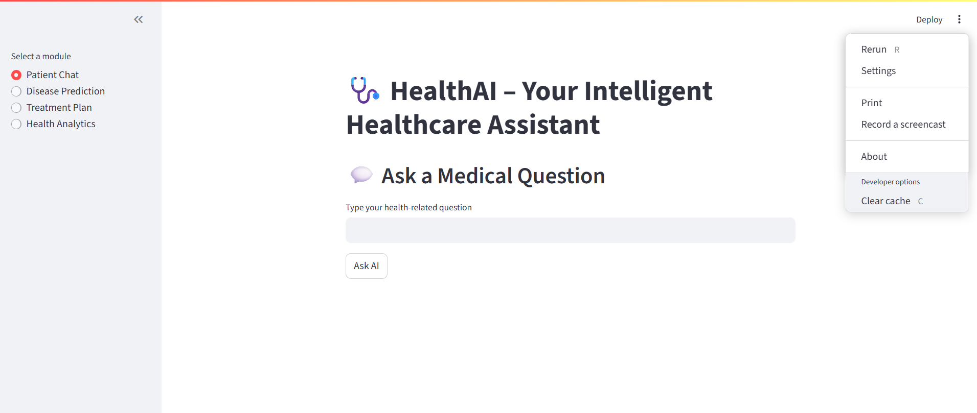

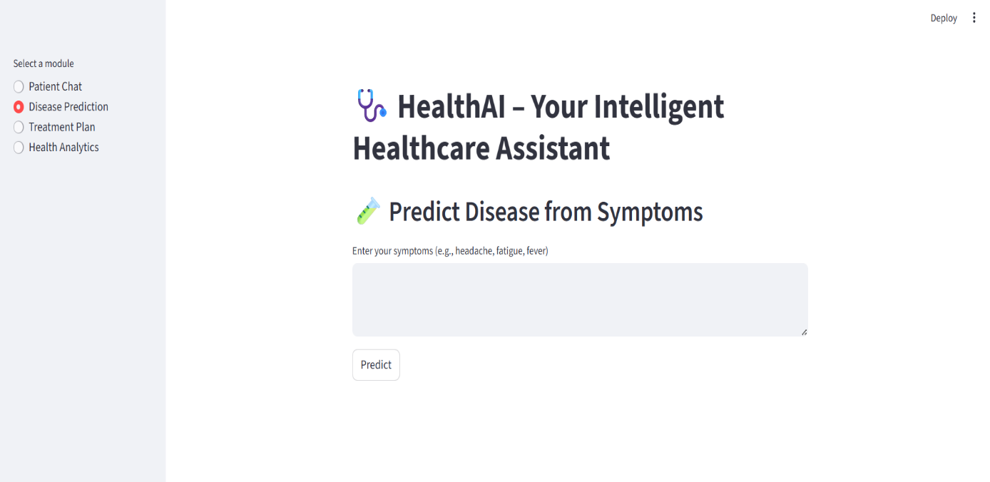

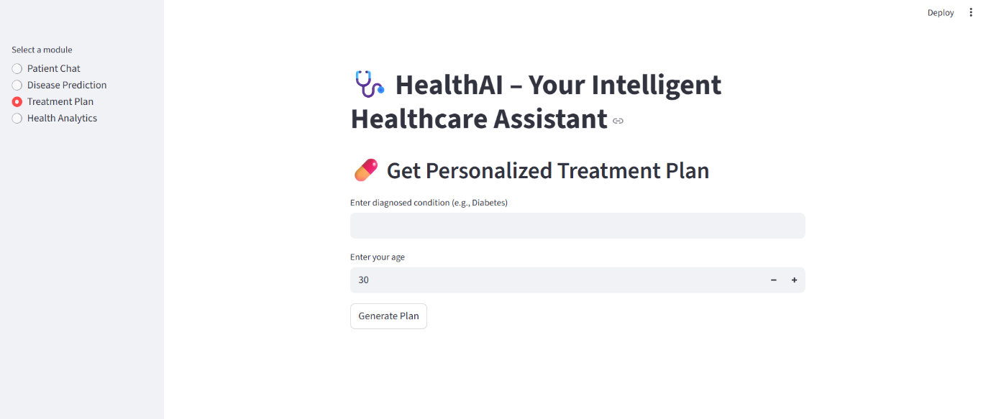

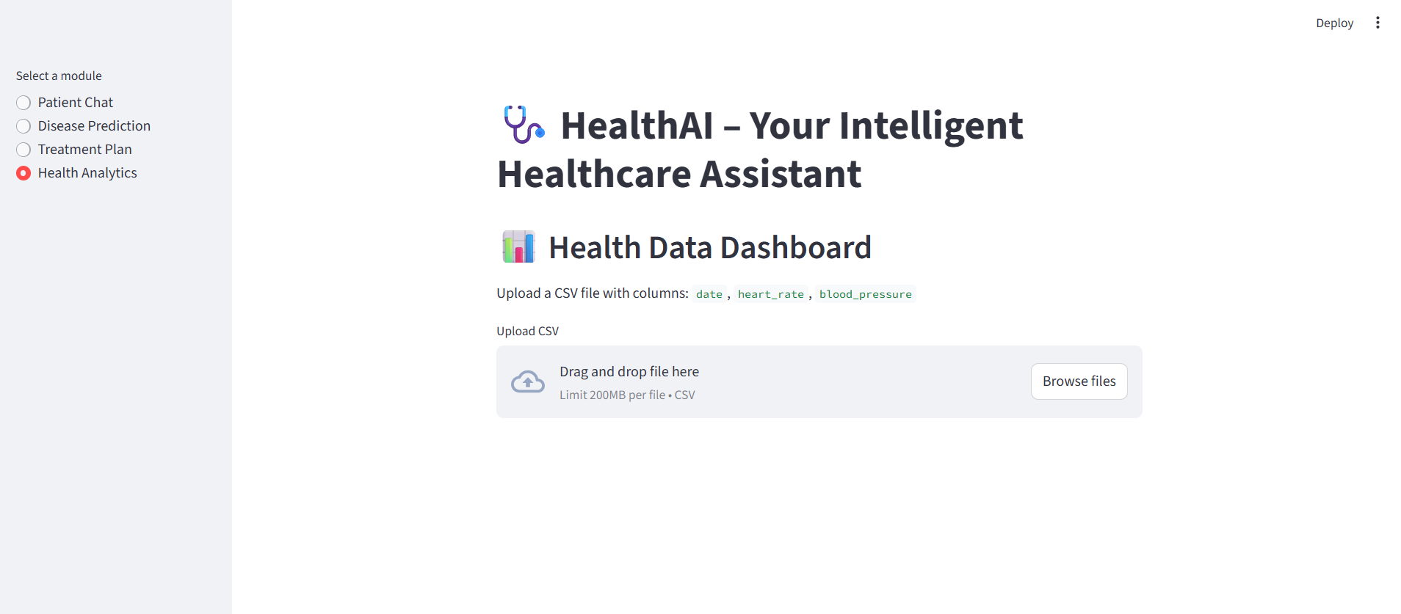

**TESTING**

Testing plays a critical role in ensuring the reliability, performance, and safety of the HealthAI system, especially given its sensitive domain—healthcare. Rigorous manual and planned automated testing were conducted to validate both the user interface and the AI model integration with IBM WatsonX services.

Objectives of Testing

* Validate the accuracy and relevance of AI-generated responses.
* Ensure stable interaction between the frontend (Streamlit) and backend APIs (WatsonX).
* Detect and resolve UI/UX flaws, logic errors, and edge-case failures.
* Maintain data privacy and input/output safety for users.

Types of Testing Conducted

1. Manual Testing

Performed throughout the development lifecycle to validate functional behavior of each module.

Front-End (Streamlit Interface):

* Verified component rendering (forms, charts, inputs).
* Ensured responsiveness across devices (mobile/tablet/desktop).
* Input validation for symptom forms and condition fields.
* Proper display of AI-generated outputs and error messages.

Back-End (API Testing):

* Used Postman to simulate requests to IBM WatsonX endpoints.
* Checked JSON response structures, latency, and error handling.
* Validated secure API key usage via environment variables.

2. Functional Testing

* Symptom Prediction Logic: Checked if input symptoms returned clinically relevant predictions.
* Treatment Plan Generation: Ensured treatment suggestions matched condition context.
* Health Graph Rendering: Validated correct chart plotting for uploaded data (e.g., heart rate, BP).
* Chat Consistency: Tested conversation flow and AI responses for repeatable queries.

3. Edge Case Testing

* Empty or incorrect symptom entries (e.g., typos, partial terms).
* Invalid condition names (misspellings or obscure terms).
* Extremely high/low values in health metrics (to test chart alerts).
* Invalid API keys or network errors (tested secure fallback and messages).

4. Planned Automated Testing (Future Scope)

* Unit Tests: For individual modules using pytest or unittest.
* Mocking APIs: Simulate IBM WatsonX responses using mock libraries.
* Frontend Testing: Plan to integrate Selenium or Playwright for UI automation.
* Component Testing: Use pytest-streamlit or equivalent for verifying component state and updates.

Challenges Encountered

* Delay in model responses due to network/API latency.
* Occasionally ambiguous outputs requiring clarification prompts.
* Model limitations in interpreting rare or region-specific diseases.

Conclusion on Testing

Testing in HealthAI confirms that the platform performs reliably under normal and edge scenarios. It ensures not only technical soundness but also builds user trust, which is essential in a healthcare context. Continued testing and model evaluation are planned as the platform scales and integrates additional datasets and user features.

**RESULT**

To demonstrate the functionality and user experience of **HEALTH AI** , a working demo and key UI screenshots have been provided:

**Live Demo: Demo-Video**

**GitHub Link: Freelance-Finder**

**Sample screenshorts:**

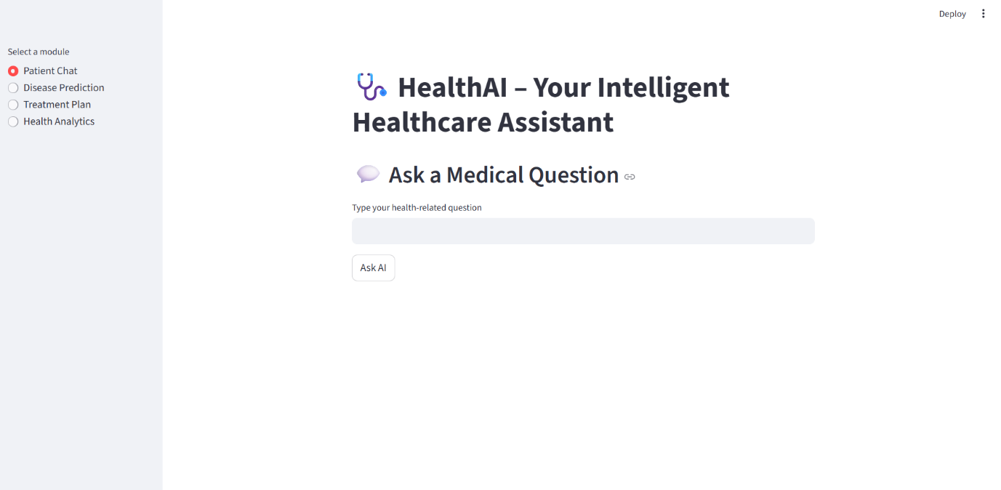

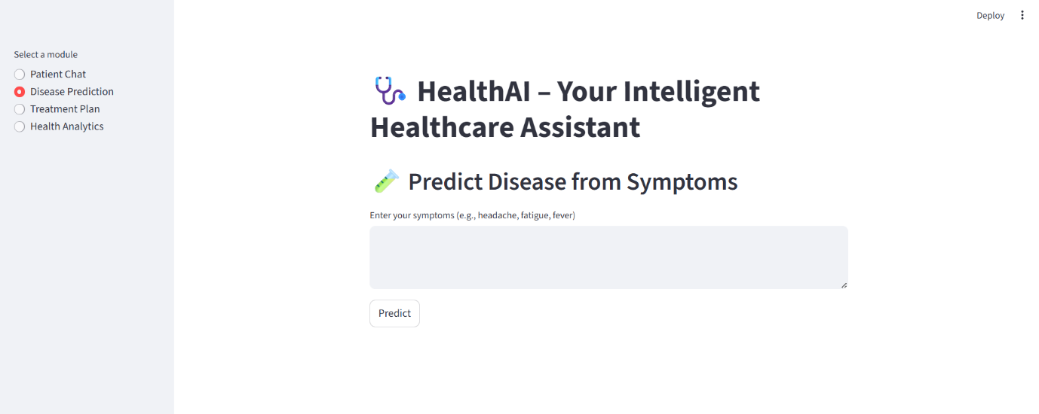



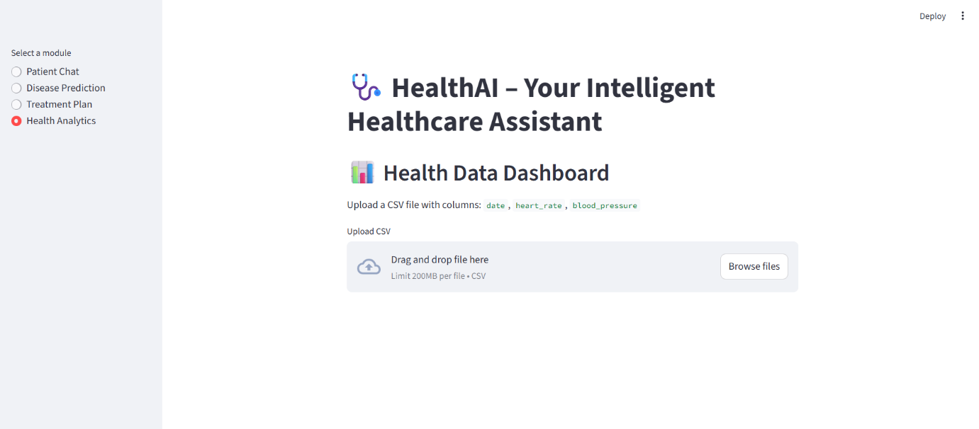

**FUTURE ENHANCEMENTS**

to improve the performance, usability, and scalability of **HealthAI**, the following enhancements are planned:

1. **Wearable Device Integration**
   * Connect with fitness trackers (e.g., Fitbit, Apple Watch) for real-time health data analysis.
2. **Multilingual Support**
   * Add regional languages to make the platform accessible to a wider audience.
3. **Mobile Application**
   * Develop a cross-platform app for better accessibility on smartphones.
4. **Voice Interaction**
   * Implement speech-to-text and text-to-speech for hands-free usage.
5. **AI Confidence & Explanation**
   * Show confidence levels and reasoning behind predictions to increase trust.
6. **Health Report & History**
   * Allow users to save, download, and track their health reports over time.
7. **Doctor Escalation**
   * Enable optional live chat or video consultations with healthcare professionals.
8. **Secure User Accounts**
   * Introduce login systems for personalized insights and saved data.
9. **Reminders & Notifications**
   * Send alerts for medications, tests, and follow-ups based on health data.
10. **AI-Based Risk Scoring**

* Generate predictive scores for conditions like diabetes or hypertension.

These improvements aim to transform HealthAI into a complete, intelligent digital health companion.

conclusion

The **HealthAI** project demonstrates the powerful intersection of artificial intelligence and healthcare, offering users a smart, accessible, and user-friendly platform for medical support. By integrating **IBM Watson Machine Learning** and the **Granite-13b-instruct-v2** generative model, HealthAI successfully delivers personalized health insights, symptom-based predictions, and treatment suggestions with a high degree of reliability and empathy.

Unlike traditional health tools that rely solely on static information, HealthAI dynamically interprets user inputs in natural language, providing AI-generated responses that are both contextually relevant and medically grounded. Its modular architecture—including **Patient Chat**, **Disease Prediction**, **Treatment Plans**, and **Health Analytics**—makes it a versatile tool capable of assisting users across various healthcare needs.

The use of **Streamlit** ensures an intuitive and responsive user experience, while **IBM WatsonX APIs** handle secure and scalable AI processing in the backend. Moreover, by embedding responsible AI practices, such as clear disclaimers, limited data retention, and privacy safeguards, HealthAI establishes a trustworthy foundation for user interaction in a sensitive domain.

This project not only showcases technical proficiency in building a full-stack AI application, but also reflects a deep understanding of **real-world healthcare challenges**—such as accessibility, early intervention, and health literacy.

As the system evolves with planned features like wearable integration, mobile access, and multilingual support, HealthAI is well-positioned to become a **holistic, AI-powered health companion**—bridging the gap between everyday users and professional healthcare services.

In summary, **HealthAI is a step toward democratizing healthcare through technology**, empowering individuals to take proactive steps toward better health with confidence and convenience.